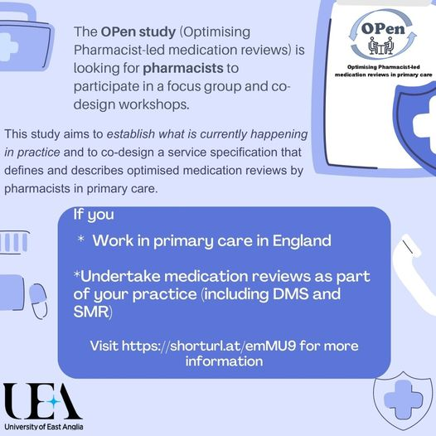**Optimising Pharmacist-led medication reviews in primary care**

Aim: Co-design and test a service specification for optimised pharmacist-led medication reviews in primary care to improve outcomes for people with long-term conditions.

**Overview**

The research team at the University of East Anglia are looking to recruit pharmacists working in community, PCNs and GP practices to participate in a focus group and 2 co-design workshops

**Participant Information and expression of interest**

For further information click on the link

<https://uea.onlinesurveys.ac.uk/expression-of-interest-practitioners-2>